COURSE 4: PYTHON FOR DATA SCIENCE, AI & DEVELOPMENT

MODULE 1: PYTHON BASICS
4.1 COURSE INTRODUCTION
- Python is one of the most popular and widely used languages in:
  - Data Science
  - Artificial Intelligence (AI)
  - Machine Learning
  - Web Development
  - Automation & Big Data
WHY PYTHON?
- Easy to learn and read
- Requires less code than many other languages
- Huge ecosystem of powerful libraries
- Beginner-friendly yet powerful for experts
COURSE DESIGN
- Suitable for beginners and experienced programmers
- Focuses on core Python + real-world applications
- Leads into Python Project courses (Data Science, AI, App Dev)

4.2 COURSE OBJECTIVES
After completing this course, you will be able to:
- Understand Python fundamentals
- Work with:
  - Data types
  - Data structures
  - Control flow
  - Functions and classes
- Read & write files
- Collect data using:
  - APIs
  - Web scraping
- Apply skills in real-world projects
📌 Pre-requisite for Python Project courses

4.3 COURSE STRUCTURE (MODULES OVERVIEW)
Module 1: Python Basics
- Types
- Expressions & Variables
- String Operations
Module 2: Python Data Structures
- Lists & Tuples
- Dictionaries
- Sets
Module 3: Python Programming Fundamentals
- Conditions & Branching
- Loops
- Functions
- Exception Handling
- Objects & Classes
Module 4: Working with Data
- Reading & Writing Files
- NumPy
- Pandas
Module 5: APIs & Data Collection
- Simple APIs
- REST APIs
- Web Scraping
- Final Exam

4.4 HELPFUL TIPS FOR COURSE COMPLETION
Step 1: Plan
- Review modules & objectives
- Set weekly goals
- Create a study timeline
Step 2: Learn Actively
- Take notes
- Download transcripts
- Highlight key concepts
- Complete all labs
Step 3: Practice & Assess
- Attempt practice quizzes
- Review mistakes
- Retake graded quizzes if needed
Step 4: Stay Accountable
- Share goals with friends/family
- Discuss concepts with peers
Step 5: Follow the Plan
- Stay consistent
- Reward progress

4.5 INTRODUCTION TO PYTHON
Who Uses Python?
- Beginners
- Data Scientists
- AI Engineers
- Web Developers
- Researchers
Python Usage Statistics
- ~80% of data professionals use Python
- ~75% of data science jobs require Python
Organizations Using Python
- IBM
- Google
- NASA
- Facebook
- Amazon
- Spotify
- Reddit

Python Capabilities
- High-level, general-purpose language
- Large standard library
- Strong support for:
  - Data Analytics
  - Automation
  - Machine Learning
  - NLP
  - Web Scraping
Popular Python Libraries
Data Science
- Pandas
- NumPy
- SciPy
- Matplotlib
Machine Learning & AI
- TensorFlow
- PyTorch
- Keras
- Scikit-learn
NLP: Natural Language Toolkit (NLTK)

4.6 PYTHON COMMUNITY & INCLUSION
- Governed by the Python Software Foundation
- Strong Code of Conduct

- Focus on:
  - Safety
  - Inclusion
  - Diversity

4.7 INTRODUCTION TO JUPYTER
WHAT IS JUPYTER?
- Jupyter Notebook is a web-based tool for:
  - Writing code
  - Visualizing data
  - Adding text, equations, and media
SUPPORTED LANGUAGES
- Python
- R
- Julia
- Others (via kernels)
WHY JUPYTER?
- Interactive coding
- Ideal for data exploration
- Easy collaboration & sharing
- Widely used in Data Science & AI

4.8 KEY FEATURES OF JUPYTER
- Interactive code execution
- Rich outputs (plots, tables, images)

- Integration with:
  - NumPy
  - Pandas
  - Matplotlib
  - Scikit-learn
  - TensorFlow
- Supports collaboration via:
  - GitHub
  - Email
  - Notebook Viewer

4.9 GETTING STARTED WITH JUPYTER
BASIC OPERATIONS
- Run a cell → Shift + Enter
- Run all cells → Run → Run All
- Insert a cell → + button
- Delete a cell → Select + press D twice
WORKING WITH MULTIPLE NOTEBOOKS
- Open new notebooks via:
  - Plus button
  - File → New Notebook
- Arrange notebooks side-by-side
MARKDOWN & PRESENTATION
- Convert code cells to Markdown
- Add titles, explanations
- Create presentations using slide mode

SHUTTING DOWN NOTEBOOKS
- Stop kernel from sidebar
- Releases memory
- “No Kernel” confirms shutdown

HANDS-ON LAB: WRITE YOUR FIRST PROGRAM

4.10 WHAT IS A TYPE?
- A type defines how Python represents and stores data.
- Every value in Python belongs to a specific data type.
- You can check the type of any value using:
type(value)

4.11 COMMONLY USED DATA TYPES IN PYTHON
1. INTEGER (int)
- Represents whole numbers
- Can be positive or negative
- Examples:
11
-5
0
- Python supports a very large (but finite) range of integers

2. FLOAT (float)
- Represents real numbers
- Includes:
  - Decimal values
  - Numbers between integers
- Examples:
21.213
0.5
0.0001
📌 Floats allow infinite precision in theory, but in practice are limited by system memory.
3. STRING (str)
- A sequence of characters
- Used to represent words or text
- Must be enclosed in quotes
- Examples:
"Hello"
"Python"
"123"

CHECKING DATA TYPES
Use the type() function:
type(11) # int
type(21.213) # float
type("Hello") # str

4.12 TYPECASTING (TYPE CONVERSION)
Typecasting means converting one data type into another.
COMMON TYPECASTING FUNCTIONS
- int()
- float()
- str()
- bool()
INTEGER ↔ FLOAT
float(2) # 2.0
int(1.9) # 1
⚠️ Important:
- Casting a float to an int removes the decimal part (data loss).
STRING TO NUMBER
int("5") # 5
float("3.14") # 3.14
❌ This causes an error:
int("Hello") # ValueError
✔️ Only strings containing numeric values can be converted.
NUMBER TO STRING
str(10) # "10"
str(3.14) # "3.14"
BOOLEAN TYPE (BOOL)
- Represents True or False
- Must start with capital letters
True
False
- Checking type:
type(True) # bool

BOOLEAN TYPECASTING RULES
Value | Converted To
True → int | 1
False → int | 0
1 → bool | True
0 → bool | False
Examples:
int(True) # 1
float(False) # 0.0
bool(1) # True
bool(0) # False

HANDS-ON LAB: TYPES
4.13 EXPRESSIONS
- Expressions are operations that Python performs.
- They are made up of:
  - Operands → values (numbers, variables)
  - Operators → symbols that perform operations (+, -, *, /)

EXAMPLE
40 + 60 + 60
- Operands: 40, 60, 60
- Operator: +
- Result: 160

4.14 ARITHMETIC OPERATORS IN PYTHON
Operator | Meaning | Example | Result
+ | Addition | 10 + 5 | 15
- | Subtraction | 5 - 10 | -5
* | Multiplication | 5 * 5 | 25
/ | Division | 25 / 6 | 4.1667
// | Integer Division | 25 // 6 | 4
📌 Note:
- In Python 3, / always returns a float
- // performs division and rounds down
ORDER OF OPERATIONS (PEMDAS)
Python follows standard mathematical conventions:
- Parentheses ()
- Multiplication * and Division /
- Addition + and Subtraction –

EXAMPLE
10 + 2 * 5
Result:
20
WITH PARENTHESES
(10 + 2) * 5
Result:
60

4.15 VARIABLES
- Variables store values in memory
- Assignment uses the equals sign (=)
EXAMPLE
my_variable = 1
- my_variable stores the value 1
- You can reuse it anywhere in the code
REASSIGNING VARIABLES
my_variable = 1
my_variable = 10
- The old value is overwritten
- Python only remembers the latest assignment
STORING EXPRESSION RESULTS
x = 40 + 60 + 60
- x stores the result 160
y = x / 60
- y stores 2.6667
You can also overwrite the same variable:
x = x / 60
CHECKING VARIABLE TYPES
type(x)
- Works the same way as checking values
- Helps debug and understand data behavior
VARIABLE NAMING BEST PRACTICES
✔️ Use meaningful names
✔️ Use underscores to separate words (snake_case)
✔️ Avoid single letters unless in short calculations
EXAMPLE
total_min = 142
total_hour = total_min / 60
- Result:
2.367
📌 If total_min changes, the final result updates automatically
→ No need to rewrite logic
WHY VARIABLES ARE IMPORTANT
- Improve readability
- Make code easy to update
- Reduce errors
- Enable reusability

HANDS-ON LAB: EXPRESSION AND VARIABLES

4.16 WHAT IS A STRING?
- In Python, a string is a sequence of characters.
- Strings are enclosed in:
  - Double quotes " "
  - Single quotes ' '
EXAMPLES
"Hello"
'Python'
"123"
"@# $%"
✔️ Strings can contain:
- Letters
- Digits
- Spaces
- Special characters
ASSIGNING (BINDING) STRINGS TO VARIABLES
name = "Michael Jackson"
- The string is bound to the variable name.
STRINGS AS ORDERED SEQUENCES
- Strings behave like lists or tuples
- Each character has an index
POSITIVE INDEXING
A = "Michael Jackson"
A[0] # 'M'
A[6] # 'l'
A[13] # 'n
NEGATIVE INDEXING
- Indexing from the end of the string
A[-1] # last character
A[-15] # first character
STRING SLICING
Basic Slicing
A[start:end]
- start → included
- end → excluded
With Stride (Step)
A[::2]
✔️ Selects every second character
A[0:4:2]
✔️ Selects every second character up to index 4
LENGTH OF A STRING
Use len():
len(A)
Example:
len("Michael Jackson") # 15
STRING CONCATENATION
- Combine strings using +
first = "Michael"
last = "Jackson"
full = first + " " + last
Result:
"Michael Jackson"
STRING REPLICATION
- Multiply string by a number
A = "Hi "
A * 3
Result:
"Hi Hi Hi "
STRING IMMUTABILITY
- Strings are immutable
- You cannot modify characters directly
❌ Invalid:
A[0] = 'm'
✔️ Correct approach:
B = A + " is the best"
- Creates a new string
ESCAPE SEQUENCES
Escape sequences begin with a backslash (\)
Escape | Meaning
\n | New line
\t | Tab
\\ | Backslash
Example
print("Hello\nWorld")
Output:
Hello
World

Raw Strings (r"")
- Prevent escape sequence interpretation
- Useful for file paths & regex
Regular String
"C:\new_folder\file.txt"
❌ Incorrect output due to \n
Raw String
r"C:\new_folder\file.txt"
✔️ Interpreted literally

4.17 STRING METHODS
- Methods return a new string
- Original string remains unchanged
upper()
A = "python"
B = A.upper()
Result:
"PYTHON"
replace()
A.replace("Jackson", "is the best")
find()
A.find("Jack")
- Returns starting index
- Returns -1 if substring not found

4.18 FORMAT STRINGS IN PYTHON
1️⃣ f-Strings (Recommended)
name = "John"
age = 30
print(f"My name is {name} and I am {age} years old.")
✔️ Supports expressions:
f"{x + y}"
2️⃣ str.format()
"My name is {} and I am {} years old.".format(name, age)
3️⃣ % Operator (Legacy)
"My name is %s and I am %d years old." % (name, age)
Specifier | Meaning
%s | String
%d | Integer
📌 f-strings are fastest, cleanest, and preferred.

HANDS-ON LAB: STRING OPERATIONS

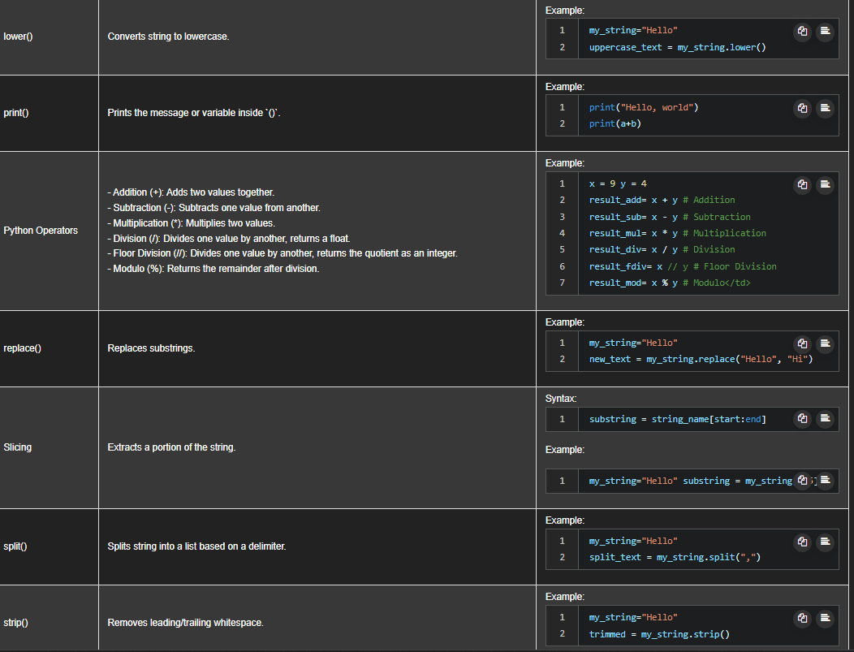
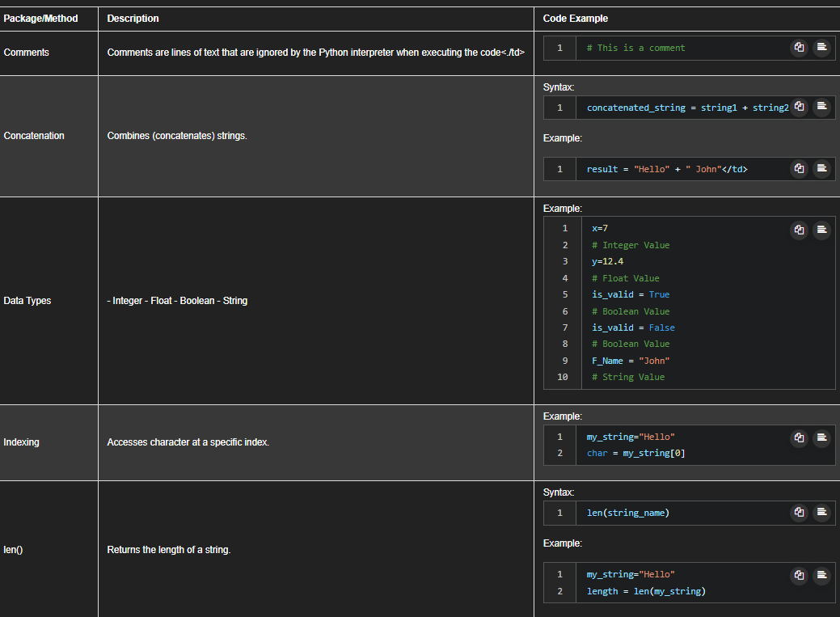
CHEAT SHEET: PYTHON BASICS
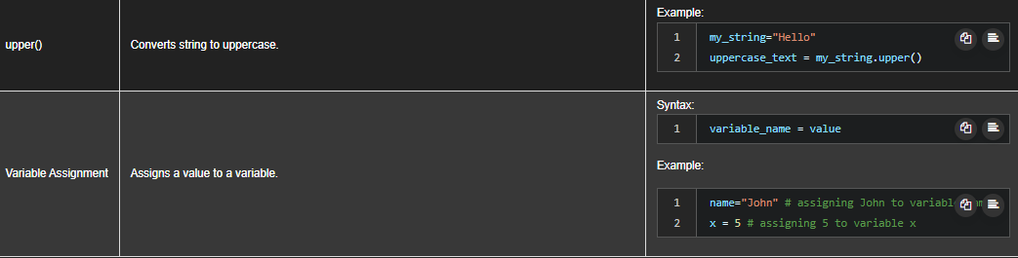

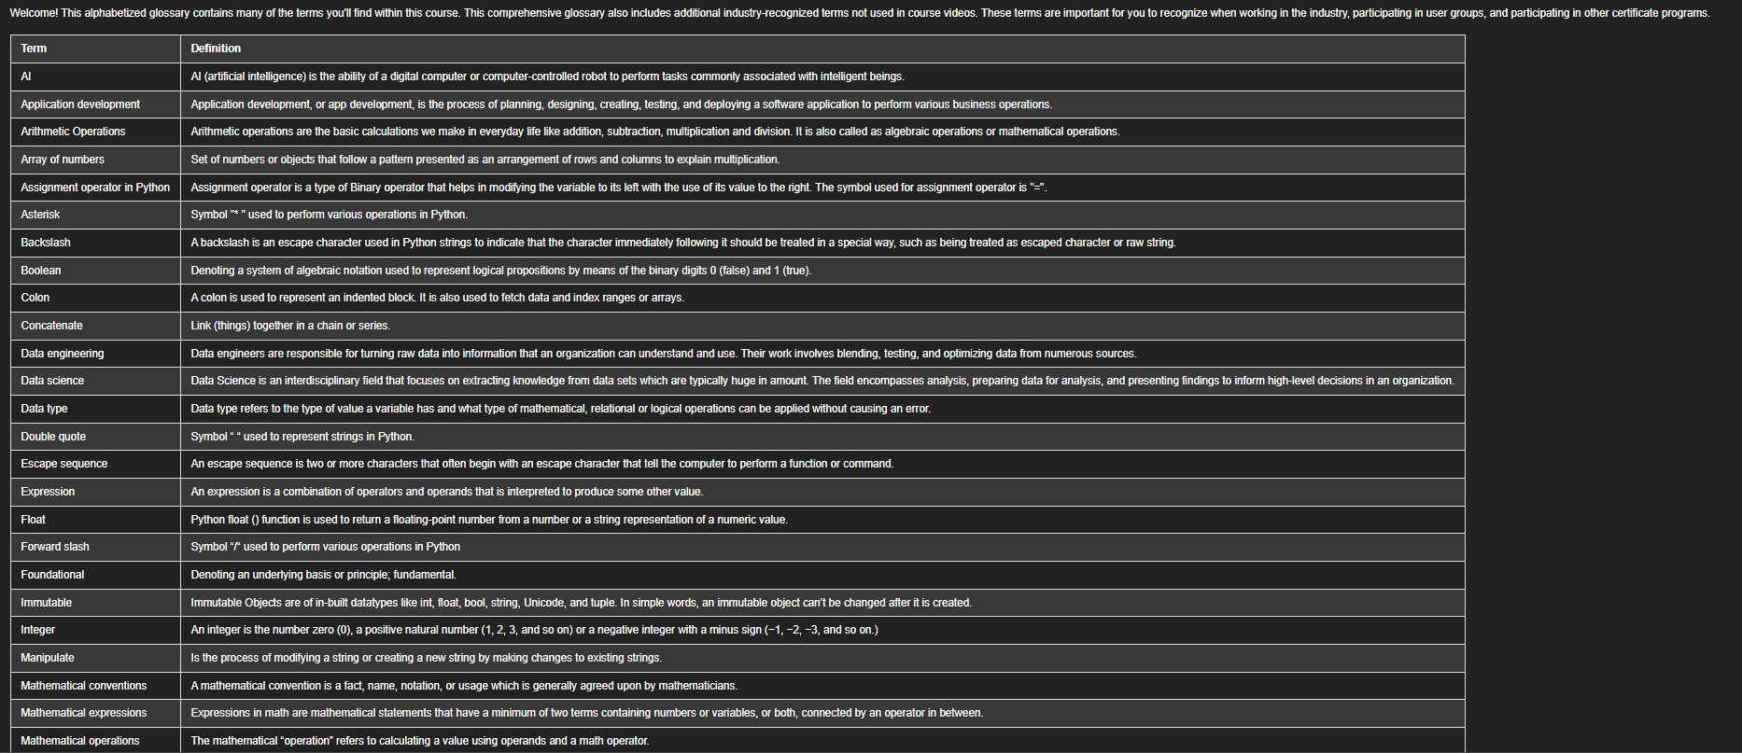
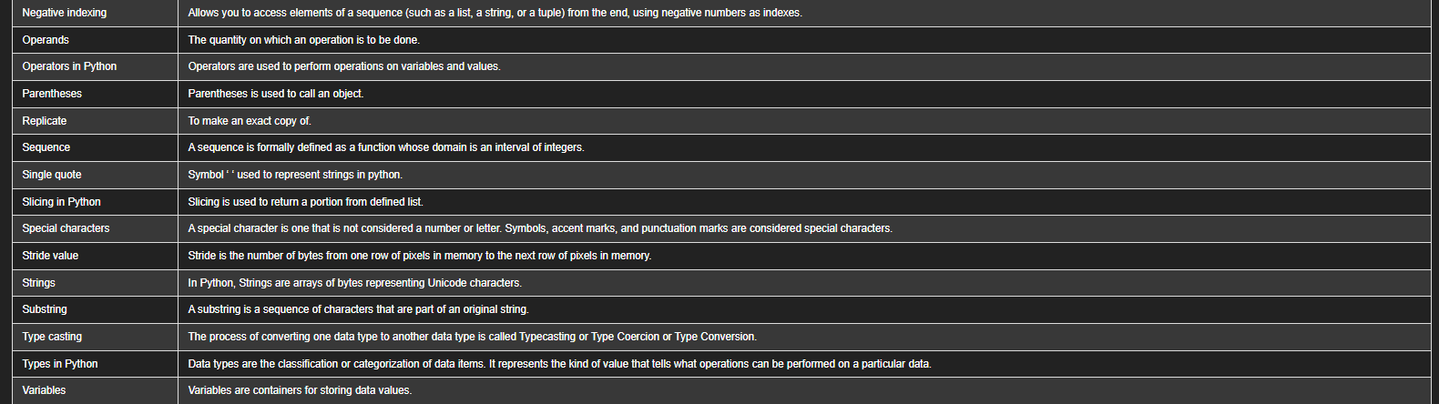

MODULE 2: PYTHON DATA STRUCTURES
2.1 LISTS AND TUPLES (COMPOUND DATA TYPES)
In Python, lists and tuples are compound data types, meaning they can store multiple values in a single variable.

2.1.1 TUPLES
WHAT IS A TUPLE?
- An ordered sequence of elements
- Written using parentheses ( )
- Elements are comma-separated
- Can store different data types (int, float, string, etc.)
- Immutable → cannot be changed after creation
Example
ratings = (10, 9, 6, 8, 9)
ACCESSING TUPLE ELEMENTS (INDEXING)
- Indexing starts at 0
- Supports negative indexing
ratings[0] # first element
ratings[1] # second element
ratings[-1] # last element
TUPLE SLICING
ratings[0:3] # first three elements
ratings[-2:] # last two elements
📌 Rule:
The ending index is one greater than the last element you want.

LENGTH OF A TUPLE
len(ratings)
TUPLE CONCATENATION
t1 = (1, 2)
t2 = (3, 4)
t3 = t1 + t2
TUPLE IMMUTABILITY (VERY IMPORTANT)
❌ Invalid:
ratings[2] = 7
✔️ Reason:
- Tuples are immutable
- Variables reference the same tuple object
ratings1 = ratings
Both variables point to the same tuple, but it cannot be changed anyway
SORTING A TUPLE
- Tuples cannot be sorted directly
- Use sorted() → returns a new list
sorted(ratings)
NESTED TUPLES
Tuples can contain other tuples (nesting)
nt = (1, 2, ("pop", "rock"), (3, 4), "disco")
Accessing nested elements:
nt[2][1] # "rock"
nt[3][0] # 3
📌 Think of nested tuples as a tree structure

2.1.2 LISTS
What is a List?
- An ordered sequence
- Written using square brackets [ ]
- Mutable → elements can be changed
- Can store mixed data types
- Can be nested (lists inside lists, tuples, etc.)
Example
L = ["HardRock", 10, 1.2]
ACCESSING LIST ELEMENTS
L[0] # first element
L[1] # second element
L[-1] # last element
✔️ Same indexing rules as tuples
LIST SLICING
L[1:3]
L[-2:]
LIST CONCATENATION
L1 = ["a", "b"]
L2 = ["c", "d"]
L3 = L1 + L2
LIST MUTABILITY (KEY DIFFERENCE)
✔️ Lists can be changed
L[0] = "Pop"

LIST METHODS
extend()
- Adds multiple elements
- Modifies the original list
L.extend(["Jazz", "Rock"])
append()
- Adds one element
- Even if it’s a list, it is added as one item
L.append(["Classical"])
DELETING ELEMENTS
del L[0] # delete first element
del L[1] # delete second element
CONVERTING STRING TO LIST (SPLIT())
s = "A B C"
s.split()
Result:
["A", "B", "C"]
Using delimiter:
s = "A,B,C"
s.split(",")
ALIASING IN LISTS
a = ["HardRock", 10, 1.2]
b = a
- a and b reference the same list
a[0] = "Banana"
👉 b also changes ❗
CLONING A LIST (AVOID SIDE EFFECTS)
b = a[:]
✔️ Creates a new copy
- Changes to a will not affect b
GETTING HELP
Use the built-in help system:
help(list)
help(tuple)
🔑 KEY DIFFERENCES: LIST VS TUPLE
Feature | List | Tuple
Syntax | [ ] | ( )
Mutable | ✅ Yes | ❌ No
Speed | Slower | Faster
Methods | More | Fewer
Use Case | Dynamic data | Fixed data

HANDS-ON LAB: LISTS
HANDS-ON LAB: TUPLES

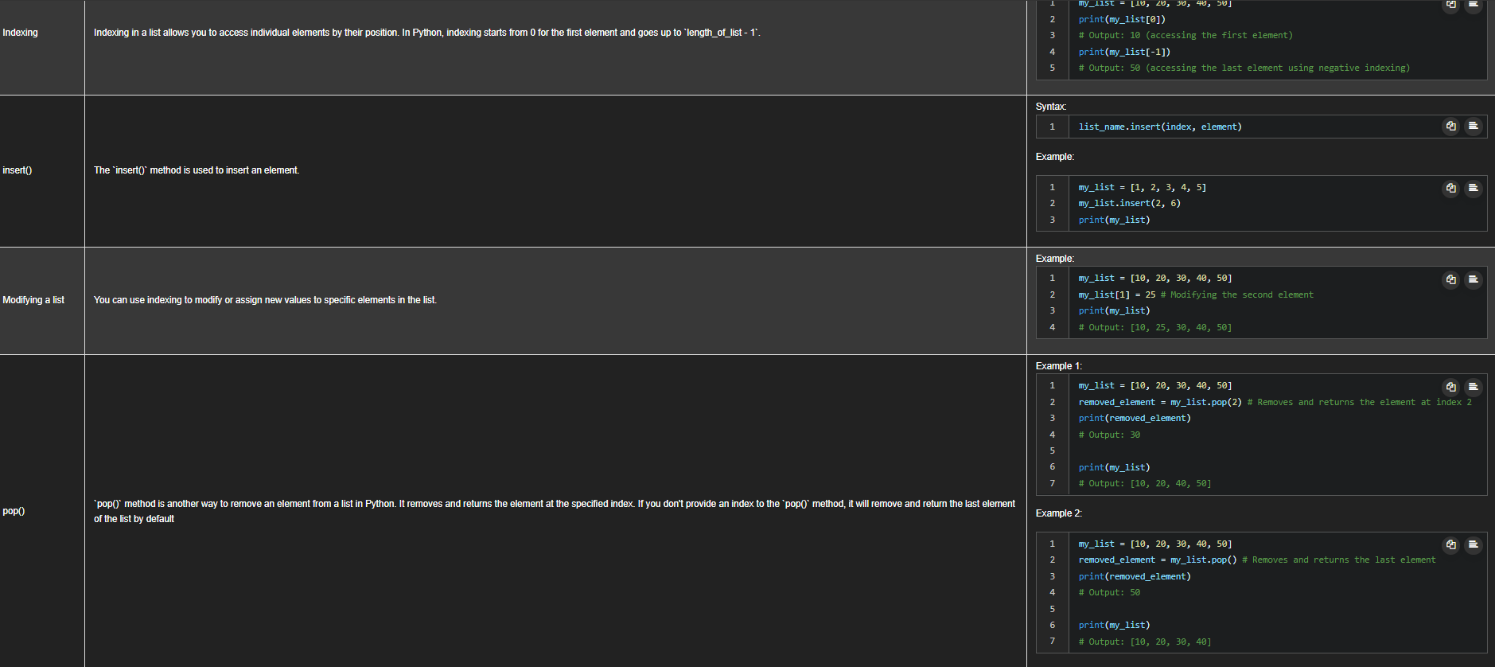
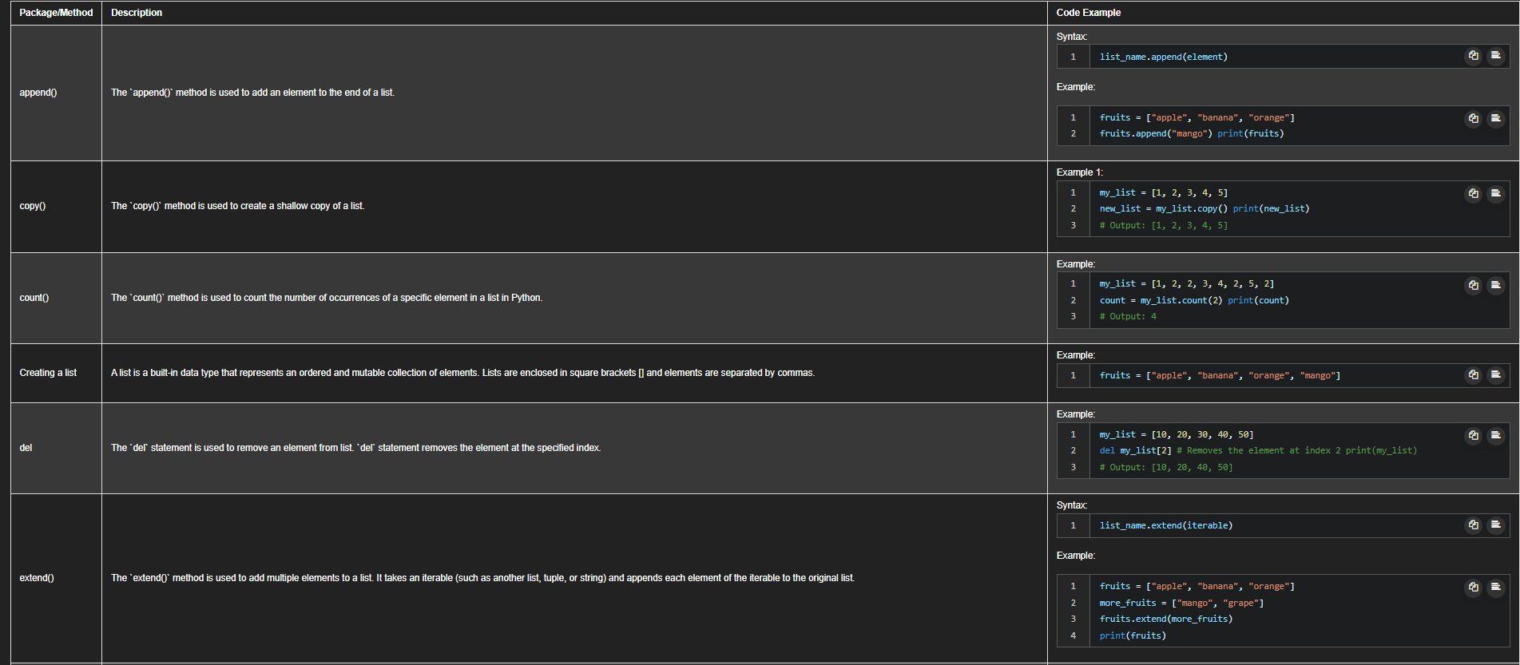
CHEAT SHEET: LISTS AND TUPLES

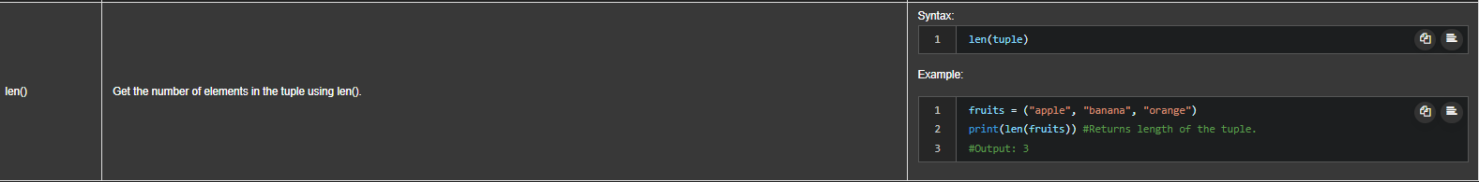
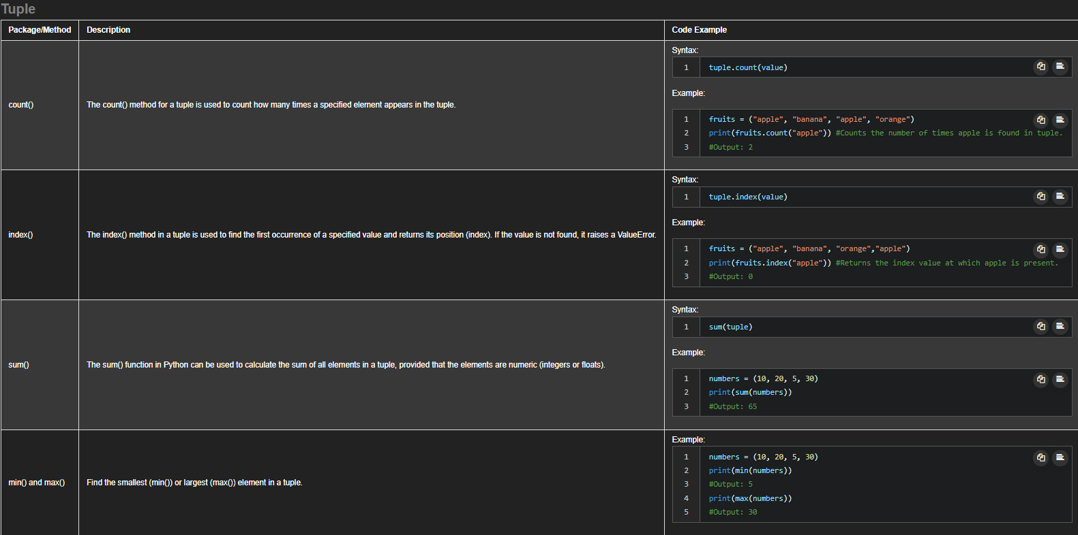
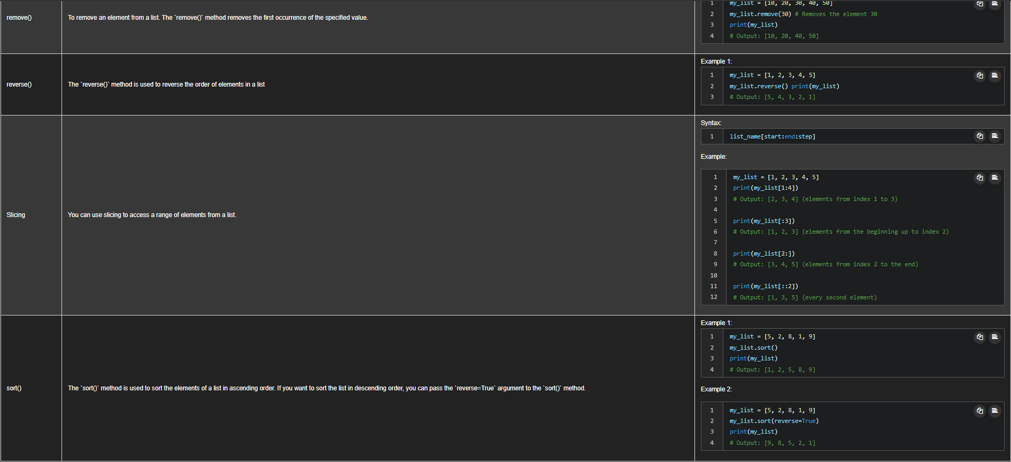

2.2 WHAT IS A DICTIONARY?
- A dictionary stores data as:
  - Keys → act like addresses (similar to indexes)
  - Values → contain the actual data
- Unlike lists:
  - Keys do not have to be integers
  - Keys are usually strings
DICTIONARY SYNTAX
- Dictionaries are written using curly braces { }
- Each key-value pair is written as:
- key : value
- Pairs are separated by commas
Example
album_year = {
"Back in Black": 1980,
"The Dark Side of the Moon": 1973,
"The Bodyguard": 1992,
"Thriller": 1982
}
DICTIONARY RULES
Keys
- Must be immutable (string, integer, tuple)
- Must be unique
- Usually written as strings
Values
- Can be immutable or mutable
- Duplicates allowed
ACCESSING VALUES USING KEYS
- Use square brackets [ ]
- Provide the key
album_year["Back in Black"] # 1980
album_year["The Dark Side of the Moon"] # 1973
📌 If the key does not exist → KeyError
ADDING A NEW ENTRY
album_year["Graduation"] = 2007
✔️ Adds a new key-value pair
DELETING AN ENTRY
del album_year["Thriller"]
✔️ Removes the key and its value
CHECKING IF A KEY EXISTS
Use the in keyword:
"Thriller" in album_year
- Returns True if key exists
- Returns False otherwise
📌 Note:
in checks keys, not values
GETTING ALL KEYS
album_year.keys()
- Returns a list-like object of all keys
GETTING ALL VALUES
album_year.values()
- Returns a list-like object of all values

DICTIONARY VISUALIZATION
Key | Value
Back in Black | 1980
The Dark Side of the Moon | 1973
The Bodyguard | 1992
Graduation | 2007
🔑 KEY DIFFERENCES: DICTIONARY VS LIST
Feature | List | Dictionary
Indexing | Integer | Key-based
Order | Ordered | Ordered (Python ≥3.7)
Lookup Speed | Slower | Faster
Use Case | Sequential data | Labeled data

HANDS-ON LAB: DICTIONARIES

2.3 WHAT IS A SET?
- A set is:
  - A collection of elements
  - Unordered → no fixed position or index
  - Contains only unique elements
- Unlike lists and tuples:
  - Sets do not allow duplicates
  - Elements have no index

CREATING A SET
- Use curly braces { }
Example
album_set = {"ACDC", "BackInBlack", "Thriller", "ACDC"}
✔️ Output:
{'ACDC', 'BackInBlack', 'Thriller'}
📌 Duplicate values are autmatically removed
TYPECASTING: LIST → SET
- Convert a list to a set using set()
- Useful for removing duplicates
album_list = ["ACDC", "ACDC", "BackInBlack", "Thriller"]
album_set = set(album_list)
✔️ Result:
{'ACDC', 'BackInBlack', 'Thriller'}
IMPORTANT PROPERTIES OF SETS
Property | Description
Ordered | ❌ No
Indexed | ❌ No
Duplicates | ❌ Not allowed
Mutable | ✅ Yes
Use Case | Unique values, math operations

ADDING ELEMENTS TO A SET
Use the add() method:
album_set.add("InSync")
✔️ Adds element if not present
❌ Adding same element again → no change
REMOVING ELEMENTS FROM A SET
Use the remove() method:
album_set.remove("InSync")
✔️ Removes the element
⚠️ Error if element does not exist
CHECKING MEMBERSHIP
Use the in keyword:
"ACDC" in album_set # True
"Who" in album_set # False
✔️ Checks if element exists in the set

2.3.1 MATHEMATICAL SET OPERATIONS
Sets support mathematical operations, often visualized using Venn diagrams.
🔹 Intersection (AND)
- Elements common to both sets
- Operator: &
AlbumSet1 & AlbumSet2
✔️ Result: elements present in both set
🔹 Union (OR)
- All elements from both sets
- Operator: |
AlbumSet1 | AlbumSet2
✔️ Result: combined unique elements
🔹 Subset
- Checks if all elements of one set exist in another
- Method: issubset()
AlbumSet3.issubset(AlbumSet1)
✔️ Returns True or False
SET OPERATIONS SUMMARY
Operation | Symbol / Method | Meaning
Add | add() | Insert element
Remove | remove() | Delete element
Membership | in | Check existence
Intersection | & | Common elements
Union | ` | `
Subset | issubset() | Containment

🔑 REAL-WORLD USE CASES
- Removing duplicates from data
- Comparing datasets
- Data cleaning
- Membership testing
- Mathematical operations

HANDS-ON LAB: SETS

CHEATSHEET: DICTIONARIES & SETS
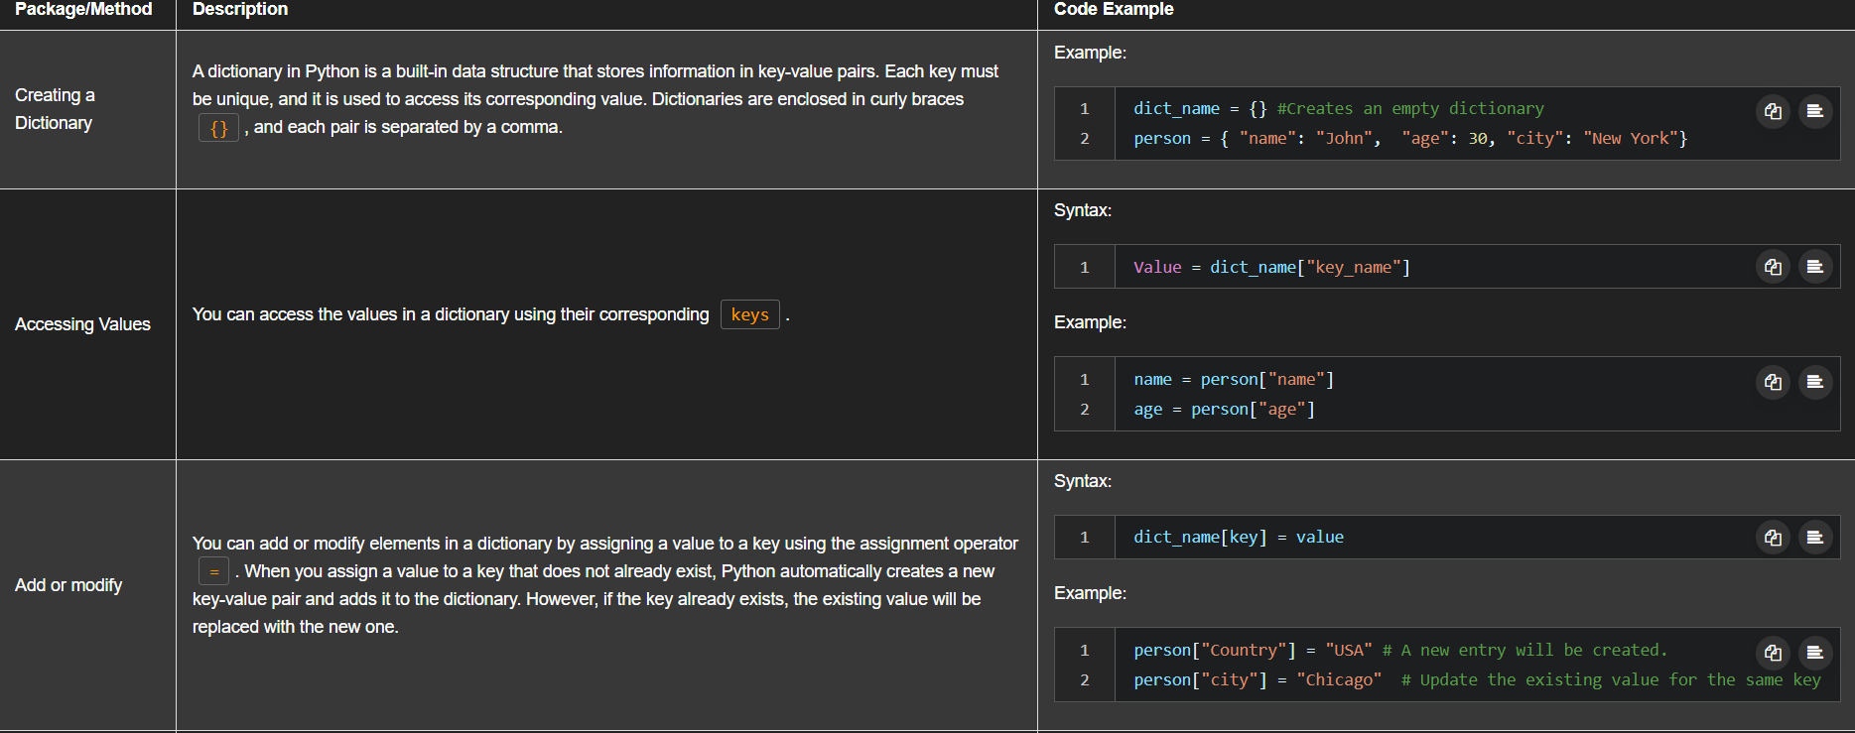
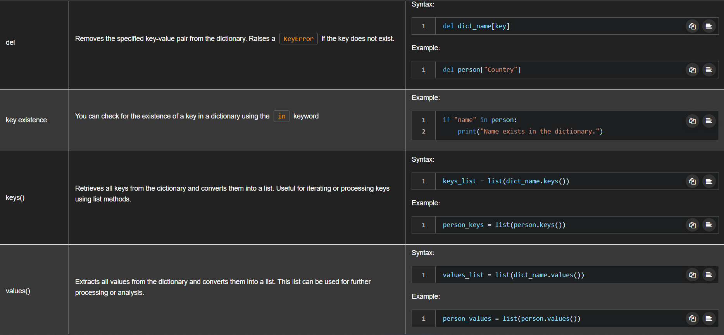
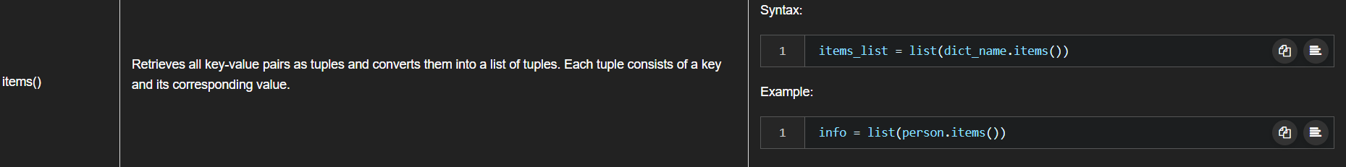

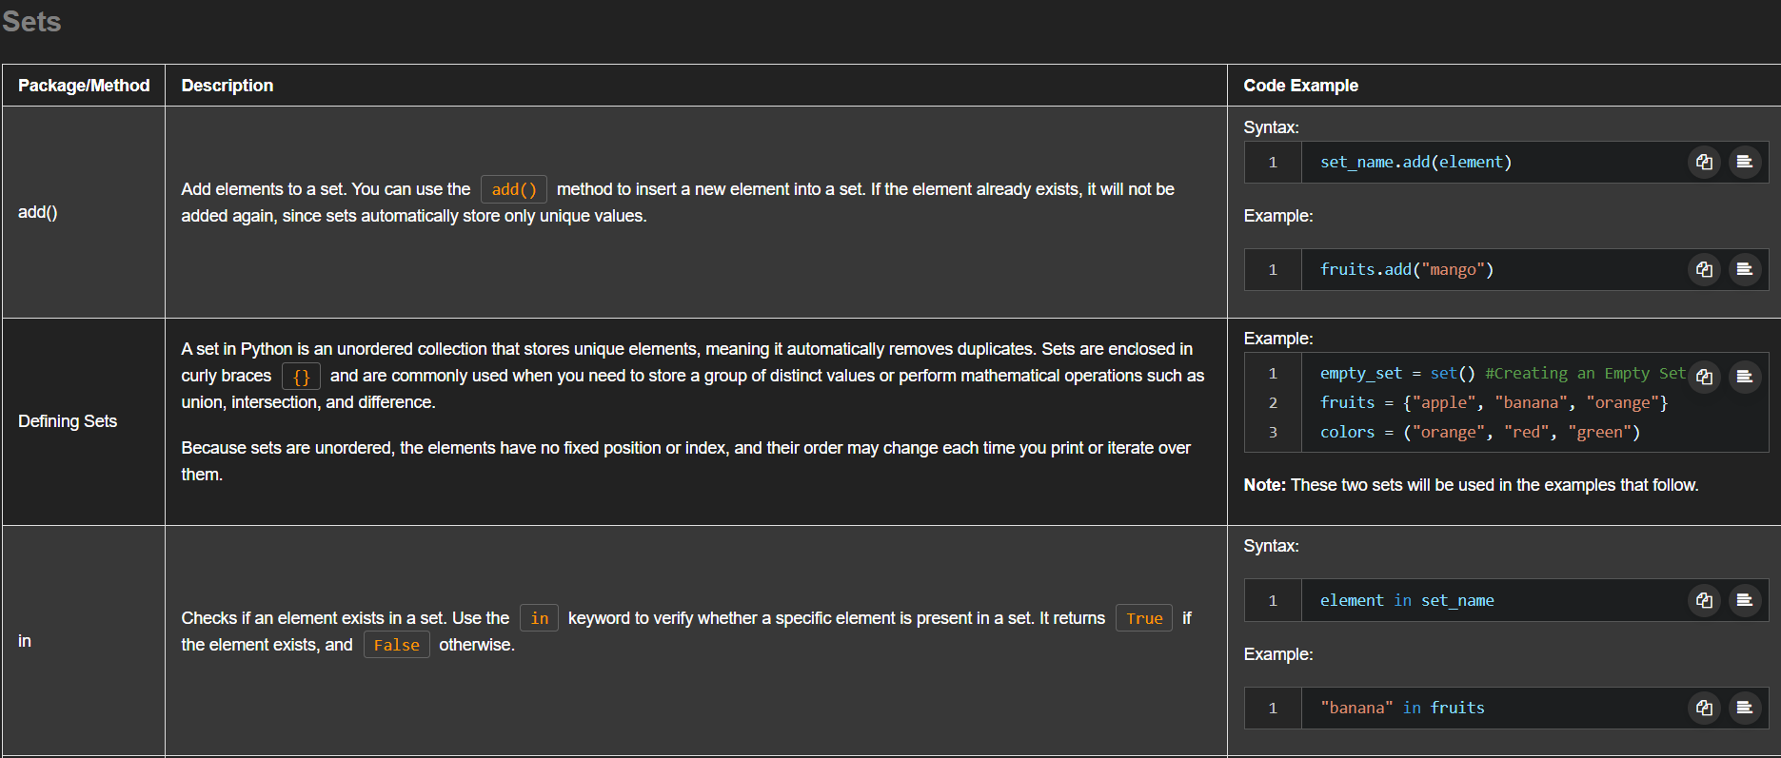
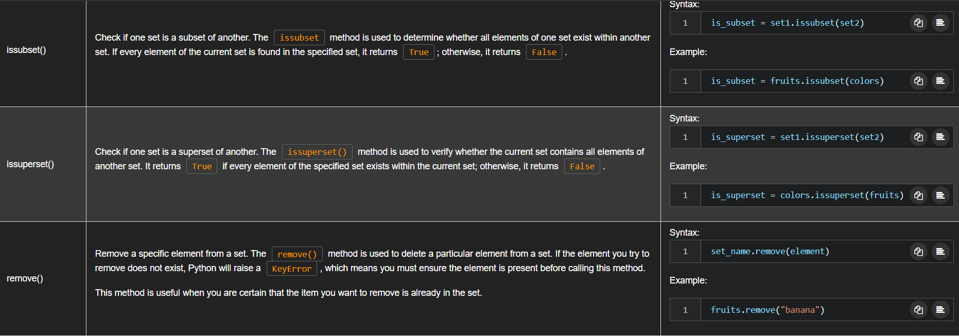
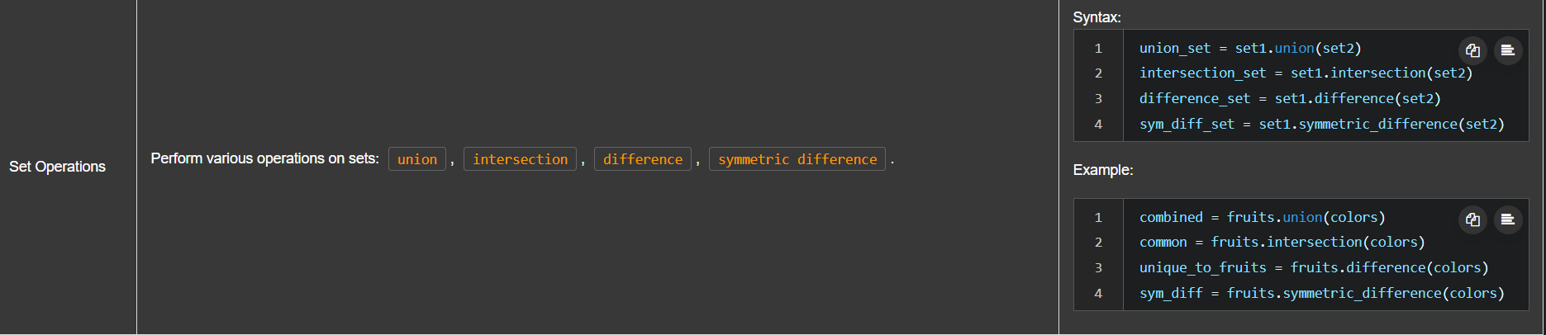

MODULE 2 GLOSSARY: PYTHON DATA STRUCTURES
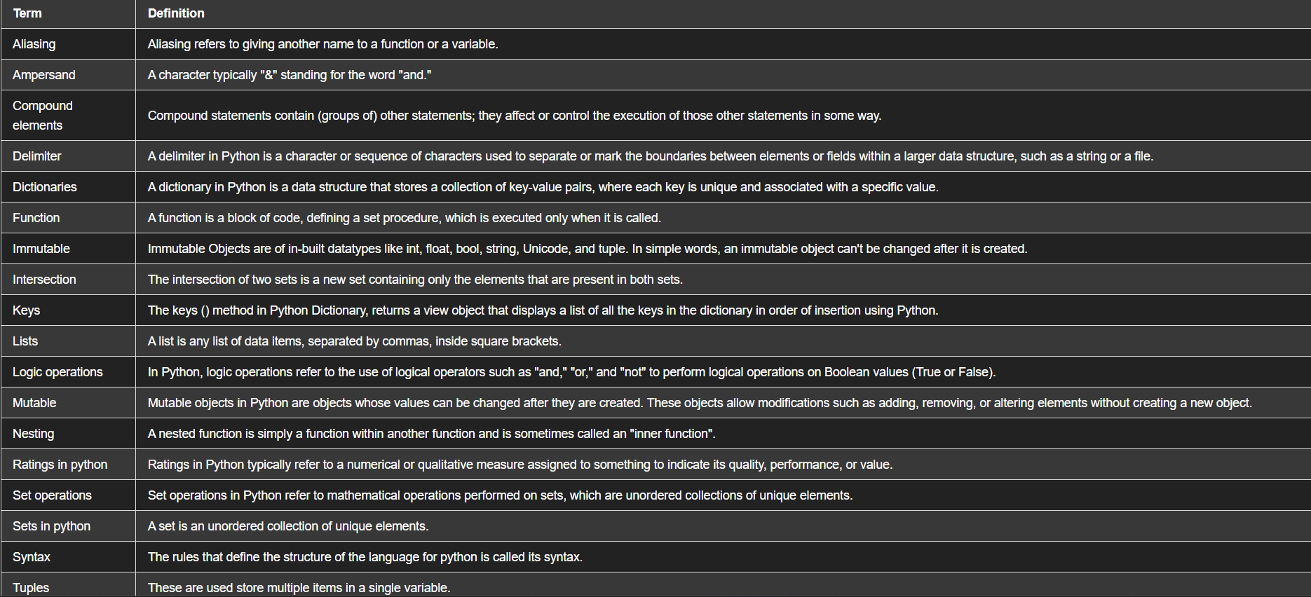
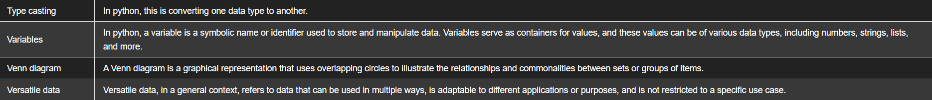

MODULE 3: PYTHON PROGRAMMING FUNDAMENTALS
3.1 COMPARISON OPERATIONS
Comparison operators compare two values (operands) and return a Boolean value:
- True
- False
🔹 EQUALITY OPERATOR (==)
Checks if two values are equal.
a = 6
a == 7 # False
a == 6 # True
🔹 GREATER THAN (>)
i = 6
i > 5 # True
✔️ Condition is true if left operand is larger.
🔹 GREATER THAN OR EQUAL TO (>=)
i = 5
i >= 5 # True
✔️ Includes the boundary value.
🔹 LESS THAN (<)
i = 2
i < 6 # True
🔹 NOT EQUAL (!=)
i = 2
i != 6 # True
✔️ True when values are different.
🔹 COMPARING STRINGS
"ACDC" == "Michael Jackson" # False
"ACDC" != "Michael Jackson" # True
📌 String comparison is case-sensitive

3.2 BOOLEAN VALUES
- Result of comparison operations
- Used for decision-making
True, False

3.3 BRANCHING
a). if statement
Branching allows execution of code only when a condition is true.
🔹 Syntax
if condition:
statement(s)
📌 Indentation is mandatory
🔹 EXAMPLE: AGE CHECK
age = 19

if age >= 18:
print("You can enter")

print("Move on")
✔️ If condition is True → code inside if runs
❌ If False → skipped
b). else Statement
Runs when the if condition is False.
🔹 Syntax
if condition:
statement(s)
else:
statement(s)
🔹 EXAMPLE
age = 17

if age >= 18:
print("You can enter the ACDC concert")
else:
print("Go see Meatloaf")
✔️ Only one block executes

c). elif Statement (Else If)
Used to check multiple conditions.
🔹 Syntax
if condition1:
statement(s)
elif condition2:
statement(s)
else:
statement(s)

🔹 EXAMPLE: CONCERT SELECTION
age = 18

if age > 18:
print("You can see ACDC")
elif age == 18:
print("Go see Pink Floyd")
else:
print("Go see Meatloaf")
Age | Output
19 | ACDC
18 | Pink Floyd
17 | Meatloaf

3.4 LOGICAL OPERATORS
Logical operators combine Boolean expressions.
🔹 NOT Operator (not)
Reverses the Boolean value.
not True # False
not False # True
🔹 OR Operator (or)
✔️ True if at least one condition is true
❌ False only if both are false
A or B
A | B | Result
T | T | T
T | F | T
F | T | T
F | F | F
🔹 Example: Album Year (70s or 90s)
album_year = 1990

if album_year < 1980 or album_year > 1989:
print("Album made in the 70s or 90s")
✔️ Executes because one condition is true
🔹 AND Operator (and)
✔️ True only if both conditions are true
A and B
A | B | Result
T | T | T
T | F | F
F | T | F
F | F | F
🔹 Example: Album Made in the 80s
album_year = 1983
if album_year >= 1980 and album_year <= 1989:
print("Album made in the 80s")
✔️ Both conditions must be true
3.5 THE RANGE() FUNCTION
The range() function generates an ordered sequence of numbers.
🔹 range(n)
- Starts from 0
- Ends at n-1
range(3) → 0, 1, 2
🔹 range(start, stop)
- Starts at start
- Ends at stop - 1
range(10, 15) → 10, 11, 12, 13, 14
📌 Note (Python 3):
- range() does not create a list automatically
- It creates a range object (efficient & memory-friendly)

3.6 FOR LOOPS
A for loop repeats a block of code a fixed number of times.
🔹 General Syntax
for variable in sequence:
statement(s)
LOOPING USING INDEX (RANGE + LIST)
Used when you need index access.
🔹 Example: Replace All Colors with "white"
squares = ["red", "yellow", "green", "blue", "black"]

for i in range(len(squares)):
squares[i] = "white"
🔹 How it works
- i starts from 0
- Runs once for each element
- Index increases automatically (i = i + 1)
LOOPING DIRECTLY OVER A LIST
Used when index is not needed.
🔹 Example
squares = ["red", "yellow", "green"]

for square in squares:
print(square)
🔹 Output
red
yellow
green
✔️ Cleaner and more readable than index-based looping

3.7 enumerate() FUNCTION
Used when you need both index and value.
🔹 Syntax
for index, value in enumerate(sequence):
statement(s)

🔹 Example
squares = ["red", "yellow", "green"]

for i, square in enumerate(squares):
print(i, square)
🔹 Output
0 red
1 yellow
2 green
📌 Very useful in data processing & analytics

3.8 WHILE LOOPS
A while loop runs as long as a condition is True.
🔹 General Syntax
while condition:
statement(s)
⚠️ Condition must eventually become false to avoid infinite loops
WHILE LOOP EXAMPLE (STOPPING ON CONDITION)
🔹 Problem
- Copy only orange squares
- Stop when a non-orange square appears

🔹 Code Example
squares = ["orange", "orange", "purple", "orange"]
new_squares = []

i = 0
while squares[i] == "orange":
new_squares.append(squares[i])
i += 1
🔹 Execution Flow
- Start at index 0
- Copy orange squares
- Stop when "purple" is found
- Loop exits automatically

3.9 FOR LOOP VS WHILE LOOP
Feature | For Loop | While Loop
Runs | Fixed number of times | Until condition fails
Best for | Known iterations | Unknown iterations
Common use | Lists, ranges | Conditional repetition

HANDS-ON LAB: LOOPS

TOPIC: BUILT-IN FUNCTIONS, USER-DEFINED FUNCTIONS & SCOPE
In Python, a function is a reusable block of code that:
- Takes input (parameters)
- Performs some operation
- Returns output (optional)
Functions help make code:
✔ Shorter
✔ Reusable
✔ Easier to read and maintain

3.10 WHY USE FUNCTIONS?
Without functions:
- Same code is written repeatedly
- Code becomes long and hard to maintain
With functions:
- Write once, reuse many times
- Call the function whenever needed
📌 Think of a function as a machine:
Input → Function → Output

3.11 BUILT-IN FUNCTIONS
Python provides many predefined functions.
You only need to know what they do, not how they are implemented.
🔹 len() – LENGTH OF A SEQUENCE OR COLLECTION
L = [10, 20, 30, 40, 50, 60, 70, 80]
l = len(L)
✔ Output: 8
Works with:
- Strings
- Lists
- Tuples
- Dictionaries
- Sets
🔹 sum() – SUM OF ELEMENTS IN AN ITERABLE
numbers = [10, 20, 30, 10]
s = sum(numbers)
✔ Output: 70

SORTING: sorted() vs list.sort()
🔹 sorted() → Function
- Returns a new sorted list
- Original list remains unchanged
ratings = [10, 9, 6, 8, 10]
new_ratings = sorted(ratings)
✔ ratings unchanged
✔ new_ratings is sorted
🔹. sort() → List Method
- Sorts the original list
- No new list created
ratings.sort()
✔ ratings is modified
🔑 KEY DIFFERENCE
Feature | sorted() | .sort()
Creates new list | Yes | No
Modifies original | No | Yes
Type | Function | Method

3.12 DEFINING YOUR OWN FUNCTION
🔹 BASIC SYNTAX
def function_name(parameter):
statements
return value
🔹 EXAMPLE: ADD 1 TO A NUMBER
def add_one(a):
b = a + 1
return b
Calling the function:
add_one(5) # Output: 6
add_one(10) # Output: 11

📌 Each function call:
- Starts fresh
- Uses the new input value

3.13 FUNCTION DOCUMENTATION (DOCSTRINGS)
Used to explain what a function does.
def add_one(a):
"""
This function adds 1 to the input value.
"""
return a + 1
Use:
help(add_one)
✔ Displays function description

3.14 FUNCTIONS WITH MULTIPLE PARAMETERS
def mult(a, b):
return a * b
Examples:
mult(2, 3) # 6
mult(10, 3.14) # 31.4
mult(2, "MJ") # 'MJMJ'
⚠️ Python allows flexible data types
✔ Useful
❗ Can cause logical errors → test your code

3.15 FUNCTIONS WITHOUT RETURN
If no return statement is used:
- Python returns None
def MJ():
print("Michael Jackson")
x = MJ()
print(x)
✔ Output:
Michael Jackson
None

🔹 EMPTY FUNCTION (PASS)
def no_work():
pass
✔ Valid function
✔ Does nothing
✔ Returns None

3.16 FUNCTION WITH PRINT + RETURN
def add_and_print(a):
b = a + 1
print("a =", a, "b =", b)
return b
✔ Can print values
✔ Can return values

3.17 USING LOOPS INSIDE FUNCTIONS
def print_list(stuff):
for i, s in enumerate(stuff):
print(i, s)
Calling:
print_list([10, 20, 30])
✔ Uses enumerate()
✔ Prints index + value

3.18 VARIADIC PARAMETERS (*ARGS)
Allows variable number of arguments.
def print_names(*names):
for name in names:
print(name)
Calls:
print_names("MJ", "Prince", "Madonna")
print_names("MJ", "Prince")
✔ Arguments packed into a tuple

3.19 VARIABLE SCOPE
🔹 GLOBAL SCOPE
- Defined outside functions
- Accessible everywhere
x = "AC"

🔹 LOCAL SCOPE
- Defined inside a function
- Exists only while function runs
def thriller():
date = 1982
return date
✔ date exists only inside thriller()
🔹 SAME NAME, DIFFERENT SCOPE
date = 2017

def thriller():
date = 1982
return date
✔ Local date → 1982
✔ Global date → 2017
No conflict ❌
USING GLOBAL VARIABLES INSIDE FUNCTIONS
If a variable is not defined locally, Python checks global scope.
rating = 9

def ac_dc():
return rating + 1
✔ Uses global rating
✔ Global value remains unchanged

GLOBAL KEYWORD
Used to modify global variables inside functions
def pink_floyd():
global claimed_sales
claimed_sales = "45 million"
Calling:
pink_floyd()
print(claimed_sales)
✔ Output: 45 million
⚠️ Use sparingly (can make code hard to debug)

READING: EXPLORING PYTHON FUNCTIONS
HANDS-ON LAB: FUNCTIONS

TOPIC: HANDLING ERRORS GRACEFULLY IN PYTHON
In Python, exception handling allows a program to handle runtime errors without crashing and to continue executing safely.

3.20 WHAT IS AN EXCEPTION?
An exception is an error event that occurs during program execution.
🔹 Example
- User enters a number when text is expected
- Program tries an invalid operation
- Python raises an exception instead of continuing normally
Without exception handling → program crashes
With exception handling → error is handled properly

WHY EXCEPTION HANDLING IS IMPORTANT
✔ Prevents program termination
✔ Provides meaningful error messages
✔ Helps programs handle unexpected user input
✔ Essential for real-world applications

try…except Block
The try–except block is the foundation of exception handling.
🔹 HOW IT WORKS:
- Python executes code inside try
- If an error occurs → jumps to except
- Matching exception is handled
🔹 SYNTAX
try:
# code that may cause an error
except ErrorType:
# code to handle the error
🔹 EXAMPLE: FILE ERROR
try:
file = open("data.txt", "r")
content = file.read()
except IOError:
print("Unable to open or read the data in the file.")
✔ If file cannot be read
✔ Python skips try block
✔ Executes except IOError

MULTIPLE EXCEPT BLOCKS
Different errors require different handling.
try:
# risky code
except IOError:
print("File error occurred")
except ValueError:
print("Invalid value entered")
✔ Specific exceptions make debugging easier
AVOID BARE EXCEPT (BAD PRACTICE ❌)
except:
print("Something went wrong")
❌ Catches all errors
❌ No details about what failed
❌ Very hard to debug in large programs
📌 Best Practice:
Always specify the exception type whenever possible.
3.21 else STATEMENT
The else block runs only if no exception occurs.
🔹 WHY USE IT?
- Confirms successful execution
- Keeps success logic separate from error handling

🔹 EXAMPLE
try:
file = open("data.txt", "w")
file.write("Hello World")
except IOError:
print("Unable to write to file")
else:
print("The file was written successfully.")
✔ Runs only if try succeeds
✔ Skipped if an exception occurs

3.22 finally STATEMENT
The finally block always executes, regardless of success or failure.
🔹 Used for:
- Closing files
- Releasing resources, Cleanup operations
try:
file = open("data.txt", "w")
file.write("Hello")
except IOError:
print("File error")
else:
print("Write successful")
finally:
file.close()
print("File is now closed")
✔ Executes even if an error occurs
✔ Ensures resources are cleaned up
COMPLETE TRY–EXCEPT–ELSE–FINALLY FLOW
Block | When it runs
try | Always (first)
except | Only if error occurs
else | Only if no error
finally | Always (last)

REAL-WORLD ANALOGY
🔒 Locked Room Example
- try → Try opening the door
- except → Handle if door is locked
- else → Enter room successfully
- finally → Close the door

READING: EXCEPTION HANDLING
HANDS-ON LAB: EXCEPTION HANDLING

TOPIC: OBJECTS, CLASSES, ATTRIBUTES, AND METHODS
In Python, everything is treated as an object.

3.23 OBJECTS IN PYTHON
Python has many built-in data types such as:
- Integers
- Floats
- Strings
- Lists
- Dictionaries
- Booleans
👉 Each of these is an object
🔹 WHAT EVERY OBJECT HAS:
- Type – what kind of object it is
- Internal representation – how data is stored
- Methods – functions used to interact with the object
📌 An object is an instance of a particular type (class).
EXAMPLES OF OBJECTS AND TYPES
- Creating an integer → creates an integer object
- Creating a list → creates a list object
🔹 EXAMPLE
a = 5 # integer object
b = [1, 2] # list object
Each creation results in a new instance of that type.

CHECKING THE TYPE OF AN OBJECT
Use the type() function:
type([1, 2, 3]) # list
type(10) # int
type("Python") # str
type({"a": 1}) # dict

3.24 METHODS OF A CLASS
Methods are functions associated with a class and are used to interact with object data.
🔹 EXAMPLE: LIST METHODS
ratings = [5, 2, 4, 1, 3]
ratings.sort()
- sort() is a method
- It modifies the object
- This changes the state of the object
ratings.reverse()
📌 Methods are called using:
object_name.method_name()

3.25 ENCAPSULATION CONCEPT
You do not need to know how methods work internally
You only need to know how to use them
✔ This is a key idea in Object-Oriented Programming (OOP)

3.26 WHAT IS A CLASS?
A class is a blueprint or template used to create objects.
- Defines data attributes
- Defines methods
- Objects are instances of a class

CREATING CUSTOM CLASSES
Example Classes:
- Circle
- Rectangle
DATA ATTRIBUTES
🔹 Circle Class Attributes
- radius
- color
🔹 Rectangle Class Attributes
- height
- width
- color
These attributes define the state of an object.

DEFINING A CLASS IN PYTHON
class Circle(object):
def __init__(self, radius, color):
self.radius = radius
self.color = color

🔹 KEY POINTS:
- class keyword defines a class
- object is the parent class
- __init__() is the constructor
- self refers to the current object
CONSTRUCTOR (__init__)
- Automatically runs when an object is created
- Used to initialize data attributes
📌 Think of self as a box containing all object data

3.27 CREATING OBJECTS (INSTANCES)
RedCircle = Circle(4, "red")
GreenCircle = Circle(2, "green")
Each object:
- Has its own data
- Belongs to the same class
ACCESSING DATA ATTRIBUTES
RedCircle.radius
RedCircle.color
Changing Attributes Directly
RedCircle.color = "blue"
✔ Attribute value changes inside the object

3.28 METHODS IN A CLASS
Methods operate on object data.
Example: Modifying Radius
class Circle(object):
def __init__(self, radius, color):
self.radius = radius
self.color = color

def add_radius(self, r):
self.radius = self.radius + r
CALLING METHODS
c = Circle(2, "red")
c.add_radius(8)
✔ self is handled automatically
✔ Object state changes
✔ Radius becomes 10

3.29 DEFAULT VALUES IN CONSTRUCTOR
Constructors can have default parameters:
def __init__(self, radius=3, color="red"):

CLASS VS OBJECT
Term | Meaning
Class | Blueprint
Object | Instance of a class
Attribute | Data inside object
Method | Function acting on object

3.30 USING dir() FUNCTION
dir(object_name)
- Lists attributes and methods
- Names with __ are internal
- Focus on readable names

READING: OBJECTS AND CLASSES
HANDS-ON LAB: OBJECTS AND CLASSES

PRACTICE LAB: TEXT ANALYSIS

CHEAT SHEET: PYTHON PROGRAMMING FUNDAMENTALS
MODULE 3 GLOSSARY: PYTHON PROGRAMMING FUNDAMENTALS

MODULE 4: WORKING WITH DATA IN PYTHON

READING FILES WITH open() IN PYTHON
(FILE HANDLING – READING TEXT FILES)
In Python, files are accessed using the built-in open() function, which creates a file object. We then use methods on this object to read data from files.

4.1 OPENING A FILE
SYNTAX
file_object = open(file_path, mode)
PARAMETERS
- File path
  - Includes file name and directory
  - Example: "Example1.txt"
- Mode
  - 'r' → Read (default)
  - 'w' → Write
  - 'a' → Append
Example
file1 = open("Example1.txt", "r")
FILE OBJECT ATTRIBUTES
Once a file is opened, we can access its attributes.
file1.name # returns file name as string
file1.mode # returns mode (e.g., 'r')

4.2 CLOSING A FILE
You should always close a file after use to free system resources.
file1.close()
⚠️ Forgetting to close files can cause memory or file-access issues.
USING THE WITH STATEMENT (BEST PRACTICE)
The with statement automatically closes the file, even if an error occurs.
EXAMPLE
with open("Example1.txt", "r") as file1:
file_stuff = file1.read()
✔ File is open only inside the indented block
✔ File closes automatically after the block

4.3 READING FILE CONTENT
🔹 read() Method
- Reads entire file as a single string
file_stuff = file1.read()
print(file_stuff)
📌 New lines appear as \n (newline character)

4.4 CHECKING FILE STATUS
Inside with block:
file1.closed # False
Outside with block:
file1.closed # True
❌ You cannot read from the file once it is closed
✔ You can still use stored content outside the block

4.5 READING LINES AS A LIST
🔹 readlines() Method
- Reads file line-by-line
- Stores each line as an element in a list
lines = file1.readlines()
Example structure:
[
"First line\n",
"Second line\n",
"Third line\n"
]

READING ONE LINE AT A TIME
🔹 readline() Method
- Reads one line per call
line1 = file1.readline()
line2 = file1.readline()
✔ Each call moves the file pointer forward

READING LINES USING A LOOP
with open("Example1.txt", "r") as file1:
for line in file1:
print(line)
✔ Best way to read large files
✔ Memory efficient
READING SPECIFIC NUMBER OF CHARACTERS
You can specify how many characters to read.
Example
file1.read(4) # reads first 4 characters
file1.read(16) # reads next 16 characters
file1.read(9) # reads next 9 characters
📌 Each read continues from the current position in the file

CHARACTER GRID CONCEPT
- File text is treated as a sequence of characters
- Each read operation moves forward through this sequence

READING: READING FILES WITH OPEN
HANDS-ON LAB: READING FILES WITH OPEN

WRITING FILES WITH open() IN PYTHON
(File Handling – Writing & Appending Text Files)
Python allows us to create, write, append, and copy files using the built-in open() function along with the write() method.

4.6 OPENING A FILE FOR WRITING
To write data to a file, we open it in write mode ('w').
SYNTAX
file_object = open(file_path, "w")

IMPORTANT POINTS
- If the file already exists, it will be overwritten
- If the file does not exist, Python will create it
USING with STATEMENT (RECOMMENDED)
Just like reading files, using with is best practice.
with open("Example2.txt", "w") as file1:
file1.write("This is line A\n")
✔ File automatically closes after the block
✔ Safer and cleaner code

4.7 WRITING DATA USING write()
🔹 write() Method
- Writes text to a file
- Accepts only strings
- Does not add a newline automatically
EXAMPLE
with open("Example2.txt", "w") as file1:
file1.write("This is line A\n")
file1.write("This is line B")
📌 \n is used to move to a new line

WRITING MULTIPLE LINES USING A LIST
You can write each element of a list into a file using a loop.

EXAMPLE
lines = ["This is line A\n", "This is line B\n", "This is line C\n"]
with open("Example2.txt", "w") as file1:
for line in lines:
file1.write(line)
✔ Each loop iteration writes one line
✔ File closes automatically after loop ends

4.8 APPENDING TO A FILE ('a' MODE)
Append mode allows adding content without deleting existing data.
KEY POINTS
- Uses mode 'a'
- Does not create a new file
- Writes at the end of the file
EXAMPLE
with open("Example2.txt", "a") as file1:
file1.write("This is line C\n")
DIFFERENCE BETWEEN WRITE & APPEND MODES
Mode | Action
'w' | Overwrites existing file
'a' | Adds content at the end

4.9 COPYING ONE FILE TO ANOTHER
We can copy content from one file to another using read + write.

STEPS
- Open source file in read mode
- Open destination file in write mode
- Use a loop to copy line by line
EXAMPLE
with open("Example1.txt", "r") as readfile:
with open("Example3.txt", "w") as writefile:
for line in readfile:
writefile.write(line)
✔ First iteration copies first line
✔ Continues until end of file
✔ Both files close automatically

READING: WRITING FILES WITH OPEN
HANDS-ON LAB: WRITING FILES WITH OPEN

